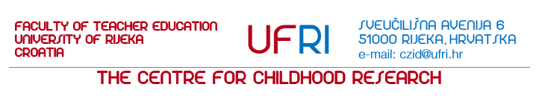

¨The best way to predict the future is to create it.¨ Peter Drucker

At its 41st session held on July 17, 2012, the Senate of the University of Rijeka accepted the decision of the Faculty of Teacher Education of July 9, 2012 pertaining to the establishment of the Centre for Childhood Research.
Recent research of childhood has been directed towards viewing issues from the perspective of the child, thereby validating the child’ s experience, its autonomy, developmental perspectives, etc. within the real context of its living as the crux of the issue. Due to these reasons, we have witnessed an affirmation of an alternative qualitative understanding of the child in the conditions of contemporary childhood, which, as such, has become a research area for those that include the issues of children's development and education among their scientific interests. These new concepts finally establish new paradigms of early and preschool education/primary school education, the ones grounded in the necessity of altering the relationship between children and adults (within the family as well as within institutions), a co-construction of the curriculum based on the idea of the educator/teacher as a reflective practitioner, the kindergarten/school as a learning community and the pedagogical theory which results from an active reflection and research of educational practice (i.e. from questioning the manners in which social

and cultural changes of the contemporary childhood can act) as starting points for the construction of a context tailored to the child’ s application limits.

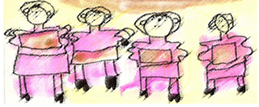

The Purpose of the Establishment and Operation of the Centre as a Structural Unit of the Faculty of Teacher Education in Rijeka is twofold:
- Strengthening interdisciplinary research in the area of the childhood (in particular up to the tenth year of a child' s life) with an objective to promote the practice of early and preschool education/primary education in the conditions of contemporary institutional childhood. We are focused on questioning contemporary research approaches appropriate to these educational contexts, which are directed towards the educational paradigm of ¨learning through research¨ and with the aim of querying and coordinating knowledge and developing new ideas based on the theoretical demands of study

programmes with the achievements of educational practice. One of the crucial questions that arises is - which abilities should a child of the 21st century possess? Accordingly, we also reflect upon the ways of structuring (physically, organisationally) institutions of early and primary education in a manner that is truly in accordance with the child' s nature and thus develops readiness for the times to come, fostering traits such as an entrepreneureal spirit, flexibility, a willingness to adapt to newly arising situations and a continual readiness for learning. In this manner new questions regarding children, the family and the community arise, and they are not only relevant to the participants directly involved in educational institutions but also to politicians, economists and entrepreneurs.
- Creating a support point for the further development of the professional identity of experts and scientists in the area of early and preschool education and primary education. The role of continuous professional training and lifelong learning is a key prerequisite for the development and consolidation of professional identity. Having this aim in mind, the Centre acts as a training area for the development of a ¨community for theoretical and practical work¨ and provides practitioners with permanent access to the academic community through the organisation of research seminars and periodical

¨partnership evenings¨ with guest lecturers and semi-annual conferences dedicated to general work improvement. Changes in Croatian society, as well as the anticipated accession of the Republic of Croatia to the European Union, require an application of lifelong learning and continuous professional training in order to respond to new demands that educators and teachers are faced with.

The action plan of the Centre for Childhood Research is launching various projects and developing interdisciplinary research (i.e.from a pedagogical, psychological and sociological viewpoint) of children and childhood (in particular regarding children up to the age of ten), their quality of living in educational institutions, kindergartens and schools, as well as programmes of lifelong learning.

Based on knowledge of the everyday life of children in a society prone to constant changes at a global level, we strive to promote research that is theoretically and methodologically anchored in interdisciplinary social research, in which childhood is understood as a social phenomenon that arises from a certain historical and cultural context. We would like to highlight the dynamic relationship between structural conditions in society, challenges in politics and children as co–constructors of their own identity and culture. We perceive children as active participants in the creation of their own childhood and thus strive to uphold children's rights and their perspectives as key issues in contemporary global research.

Lidija Vujičić, Ph.D., Assistant Professor,
Head of The Centre for Childhood Research,
e-mail: lidija.vujicic@ufri.hr
